**Group 3 Cultural map of Edinburgh**

**Group Github link:**

<https://github.com/LinYeru/culturalmap.git>

**General view:**

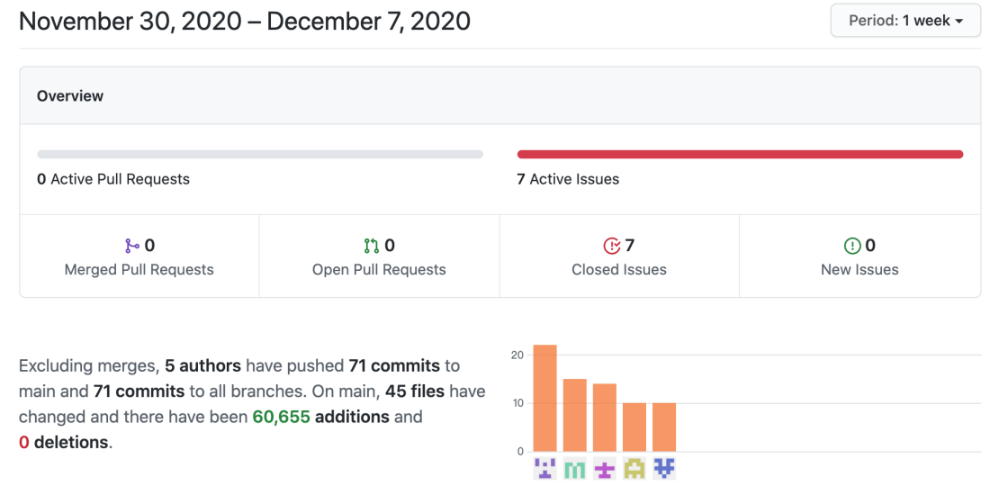

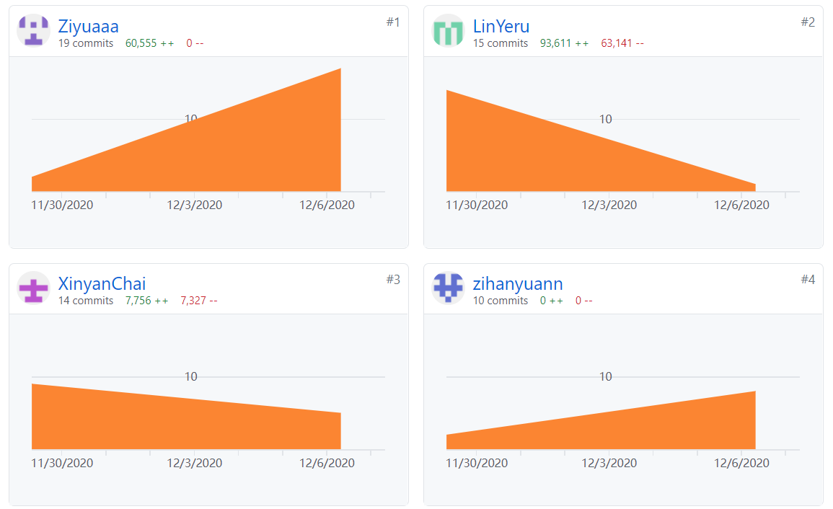

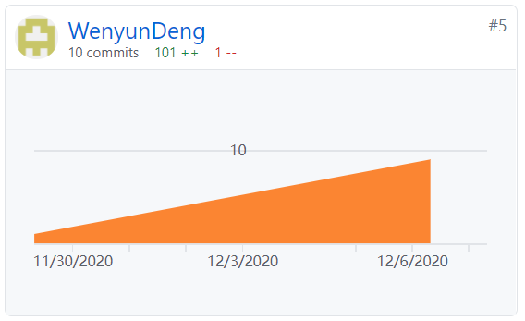

**All commits:**

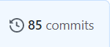

**Issues:**

We raised 7 issues and then all closed by our menbers.

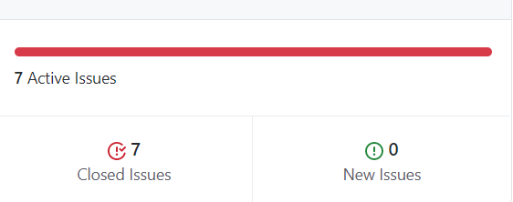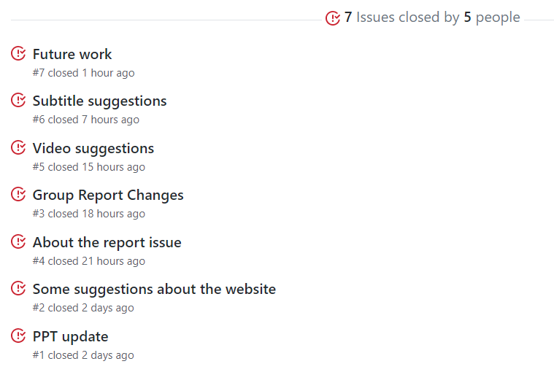

**Individual:**

**（1）Github handle:** LinYeru

**The number of commits:**

**The good, informative commits messages and explanations:**

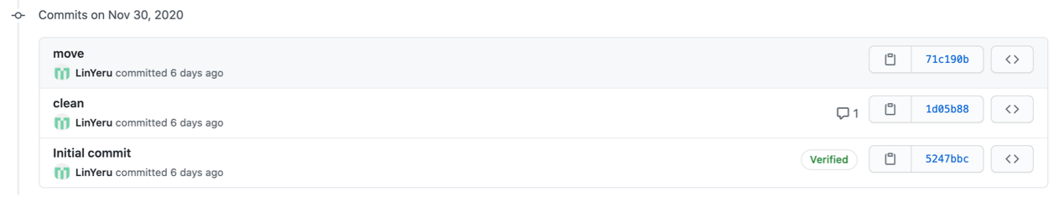

**Initial commit:** First time to use Github and set up for our group, just try to push and pull.

**Clean:** Clean the data. For clean part, our goal is to clean the data to analyze the year and position of arts with changing format, drop the useless columns and connect and output different data document. Also, I drew the plots after data cleaning. I used pandas, numpy, Matplotlib.

The brief ideas show below.

1）Change format: In files, I found that the year part had so many formats, like 2019-4，2019/4 both mean the April in 2019. I only need the year part. So I need to simplify with the use of Pandas and Numpy. In addition, I need to change the year format from object to float and make sure the positions(x,y) are all float.

2）Drop the useless columns: I need to drop the irrelevant columns to make our data clean. Also I need to drop NaN parts. I only keep the name, date, x, y, sorts

3）Connect and output different data document: After modifying the corresponding column names in different files have the same name, I need to connect them and integrate into a new file. I output it and also 4 small documents for arts with different centuries data.

4）Plots: Draw analysis pictures for the data, including heatmap and space distribution with Folium and some relationship charts with Matplotlib.

**Move:** Move the clean the data document(Jupyter Notebook) into the new folder named ‘Data cleaning - Physical map’ to clarify data is used for physical map.

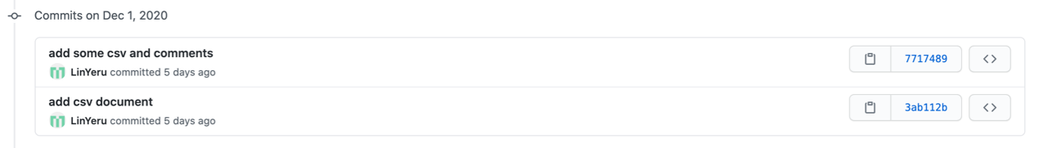

**Add csv document:** Add the public art.csv and street art.csv in the same folder to check the mistakes in the Jupyter Notebook document.

**Add some csv and comments:** Also add some markdowns in the data Jupyter Notebook document to explain my data cleaning logic.

**Add web:** Start to make website for virtual interaction. To check the heatmap and position map made for python can also be shown on the website with the use of Leaflet.js.

**Small changes:** Set the new folder named ‘web’ for website.



**Web update:** Using html and css to make the layout and animation of website. And add aos.js to make the simple animation, like zoom in, fade down and so on.

**Timeline csv:** Clean the data for timeline.js. And make it and put it into the website.

**Move:** Move the timeline related documents to the new folder named‘Data cleaning - Virtual Timeline’.

**Add wordcloud:** Use wordcloud to analyze the most frequent use words to judge which types are most used in public art.

**Web update:** Perfect the websites for changing the logic and improve the charts.

1. Change the logic: It contains 4 parts: introduction, instruction, interactive timeline and general.
2. Improve the charts: Use chart.js to make the plots made by python beautiful and dynamic.

**Web Final Version:** Determine the last version of website. Add the wordcloud on the website and enlarge the size of fonts.

**Update our public website link:** Post the website link to public using Github. Here is the website link:<https://linyeru.github.io/Map/>

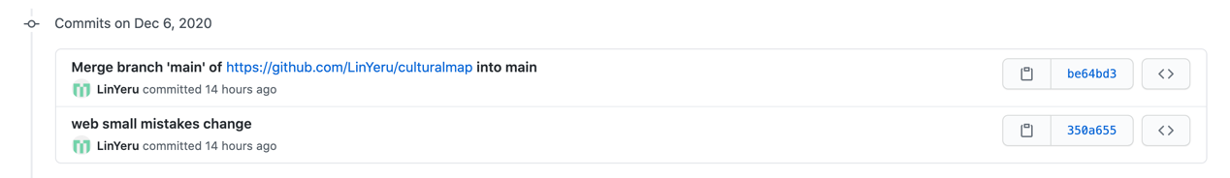

**Web small mistakes change:** Change some words on the website. I found I wrongly spelt our one group member’s name and changed it.

**Created issue:**

**Contribution to discussion on someone else’s issue and close the issue:**

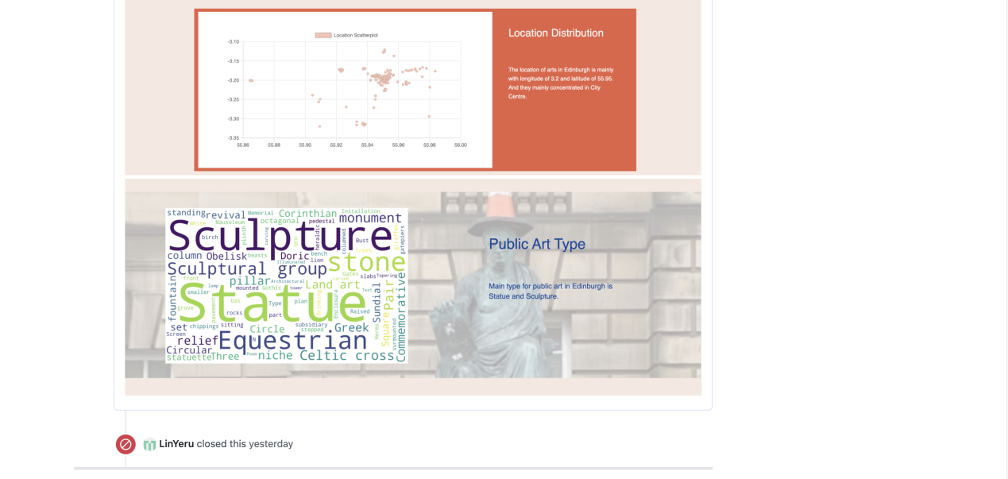

**（2）Github handle:** Chaixinyan

Link to our group <https://github.com/LinYeru/culturalmap.git>

**The number of commits:14**

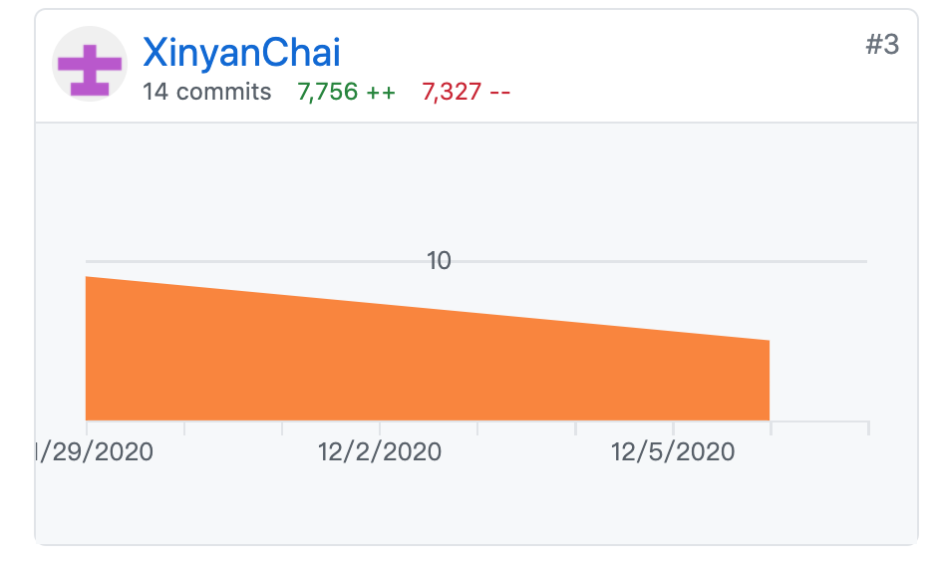

**Commits I have made:**

**Submit the final PPT**. Do the proofreading of the hole PPT. Output the document format as PDF. This is our final PPT document.



**Change the file.** Change the filein our github, which makes the document look clearer.



**Upload final report.** (1) This is our group's final report. On the basis of the previous draft, the structure of the article is sorted out. We do the proof reading and change some spelling mistakes. We put the picture into the appendix and add some information of data cleaning in the data analysis part. (2) I also fixed some text errors in PPT.



**Add some changes in the draft.** Find some problems of pervious data analysis draft. It is better to divided it into 3 parts and write this part more logically. Considering this problem, I rewrite the text structure of the data analysis section.



**Change the PPT.** Add some detail information about our project. (1) Add some detail information about the type analysis of the public art. (2) Add the technology introduction of web technologies we used in our interactive screen.



**Upload the draft.** I write the data analysis part of our final report. Put all our graphs made by python into the draft. Write some detail information and findings of these graphs.



**Change the python data file.** According to some suggestions on my group members. I added some coding of our simple statistic. I used the coding to show the public art name of the earliest one and the latest one. Also add the number of public art which emerged in the last decade. These data are used to improve our report.



**Creat the python data file.** I find that our group's data analysis only including doing the data cleaning and make the charts. I do some simple statistic of the public art for our report. Through this analysis, we can know how many public art are there in the Edinburgh. Which is the earliest one and Which is the latest？How much public art emerges each century. Have a general understanding of Edinburgh public art.

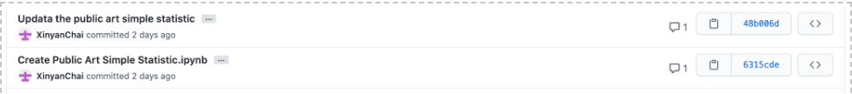

**Change the PPT for final submission**. (1) Rearrange the logic of the PPT. Separate the physical presentation from the interactive screen and change the story board in our final ppt, which can make it more clear. (2) Rethink the limitation of our prototype, write the reflection.

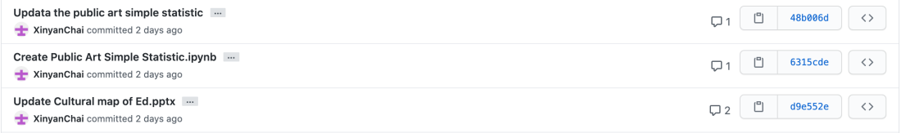

**Upload the ppt.** Make the PPT for the Thursday presentation. 

**Created issue:**

**Issue(1)**

I create an issue about our interactive website. After the presentation, I find some problems of our website and give some suggestions on our final website submit

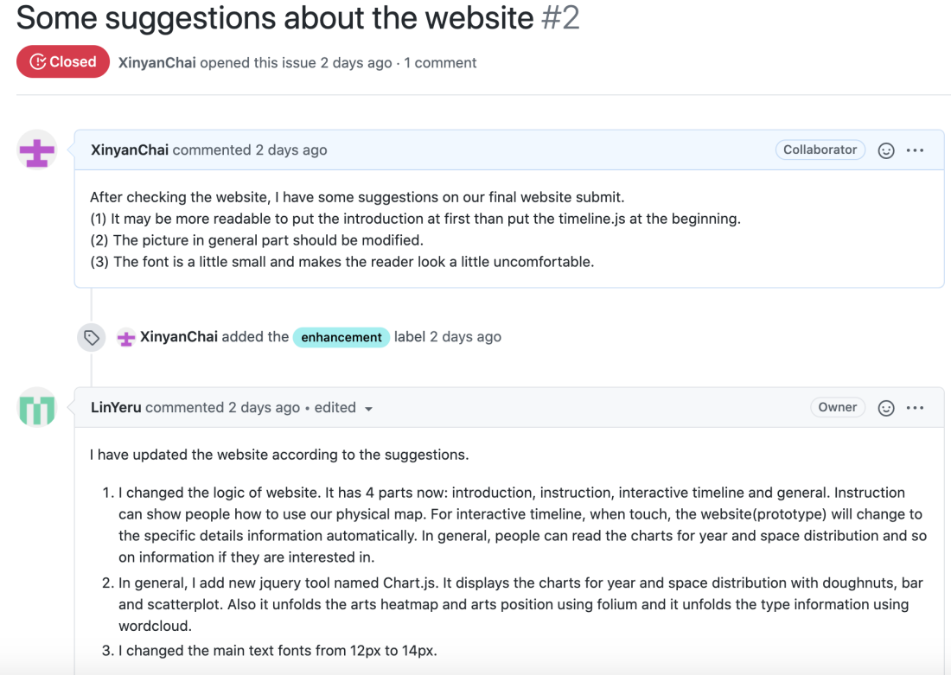

Issue(2)

Give our video maker some suggestions and hope our group members can also give some suggestions to our videos.

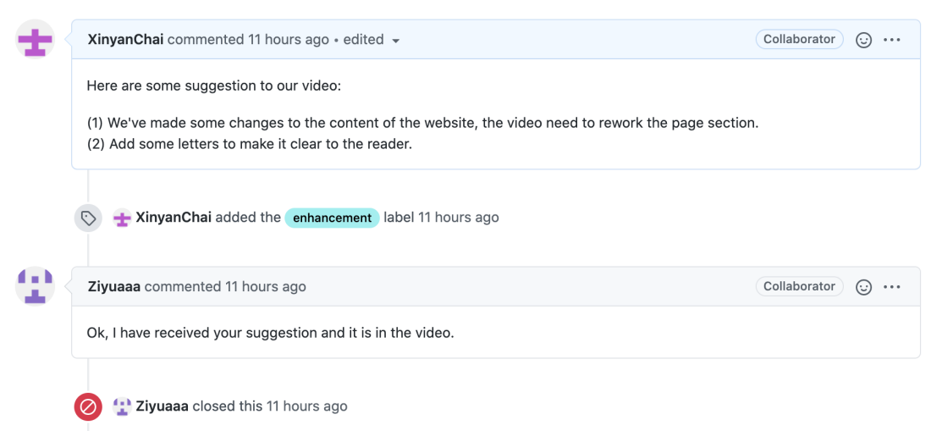

**Closed the issue:**

Yeru and Zihan added an issue about the PPT. I changed the content of the PPT according to their suggestions and close this issue.

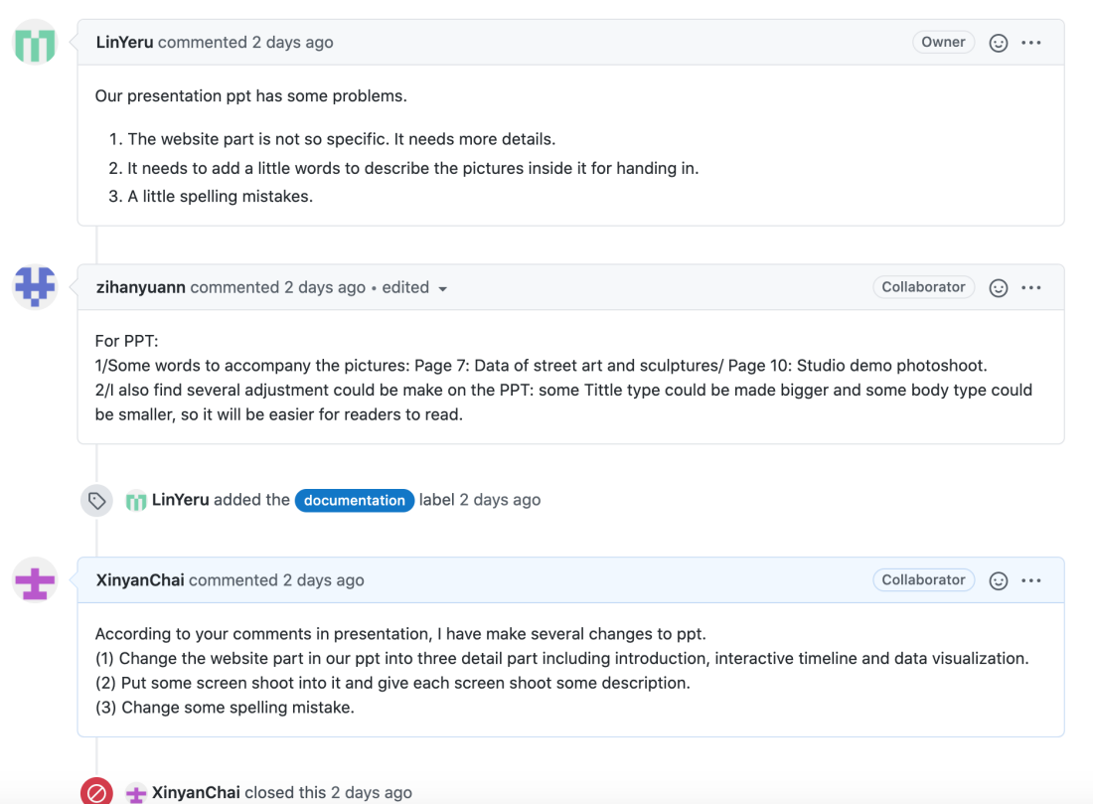

**（3）My github handle**: zihanyuann

**Link to our group repository**：<https://github.com/LinYeru/culturalmap>

**Number of commits:** 10

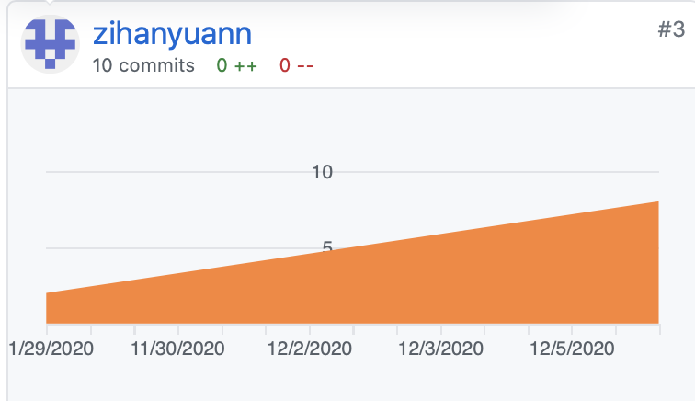

**Commits that I have made:**

The video script and group report part. I've uploaded the drafting versions of our group report to the repository and talked about the problems in the issues channel.





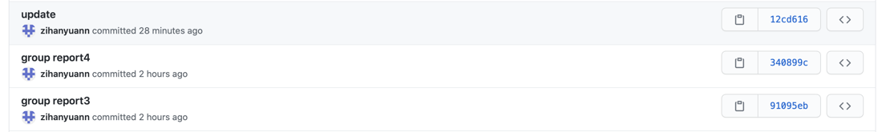

For the final submission, I find some documents were too messy in the final submission area and changed the places. I've also arranged some pictures to make the placing of the documents more logical.

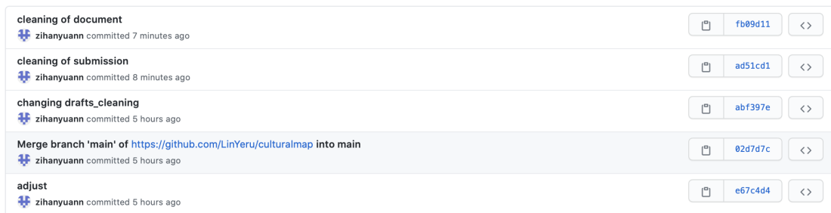

**Creating issues:**

I created an issue for the problems identified in the report and for group members to discuss together. Changes were made and report versions were iterated through the discussions. We talked about issues revolving on the context, style, and some changes of the texts were modified throughout the process.

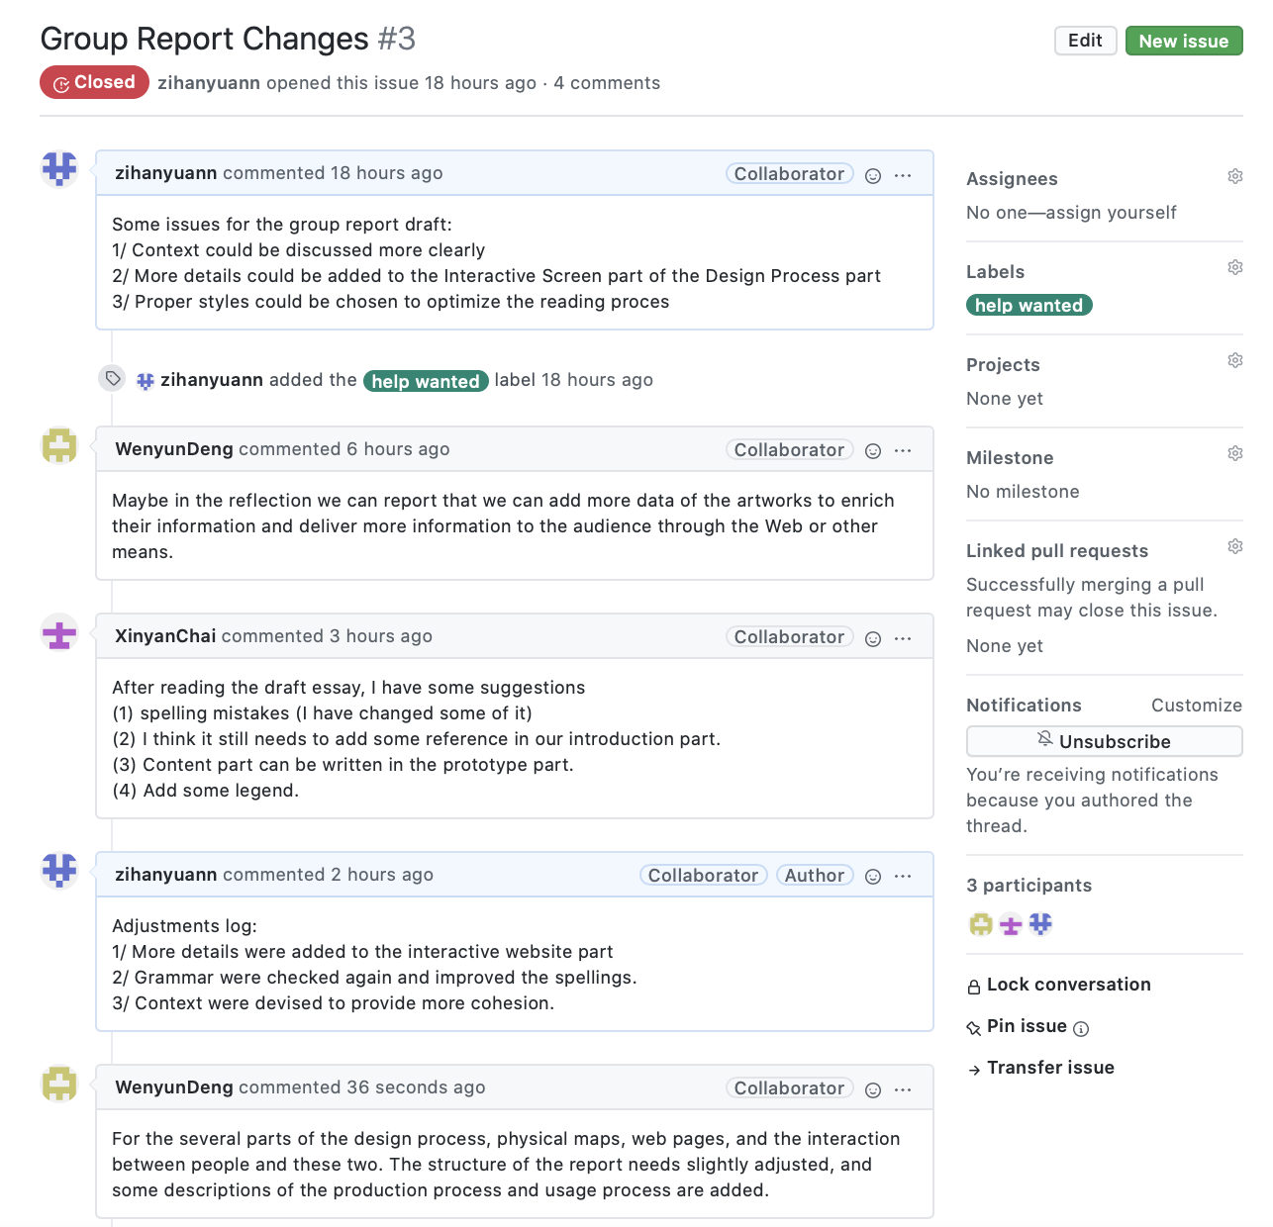

**Contributing on someone else's issue:**

Our group member Ziyu raised the issue that our group report should be taken to Adobe Illustrator to adjust the layout. We found this is crucial for optimizing the reading experience and adjust the report using AI after using Pages.

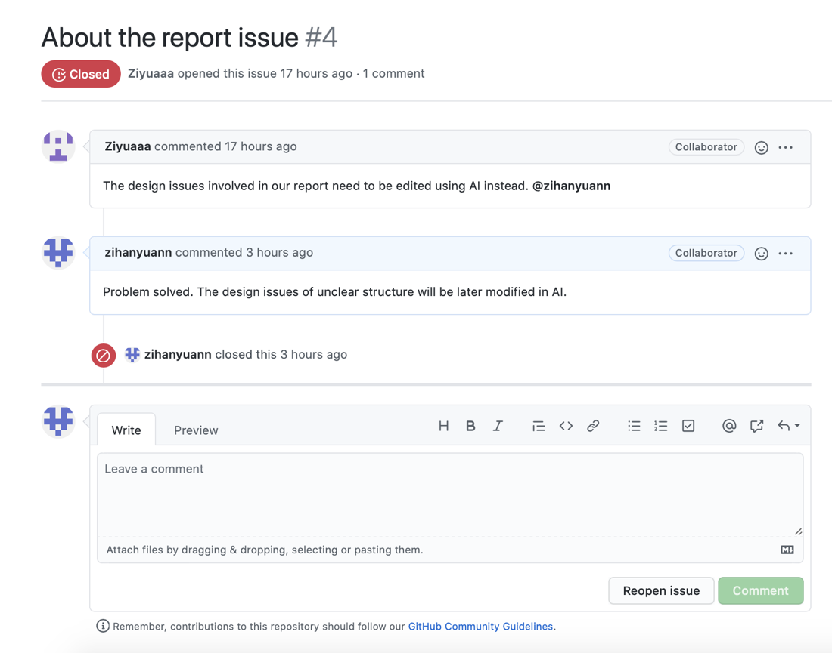

For the discussing the issue of our PPT raised by Yeru, I contributed thoughts for adding words and also enhancement for the type arrangement for the PPT for readers to read more easily.

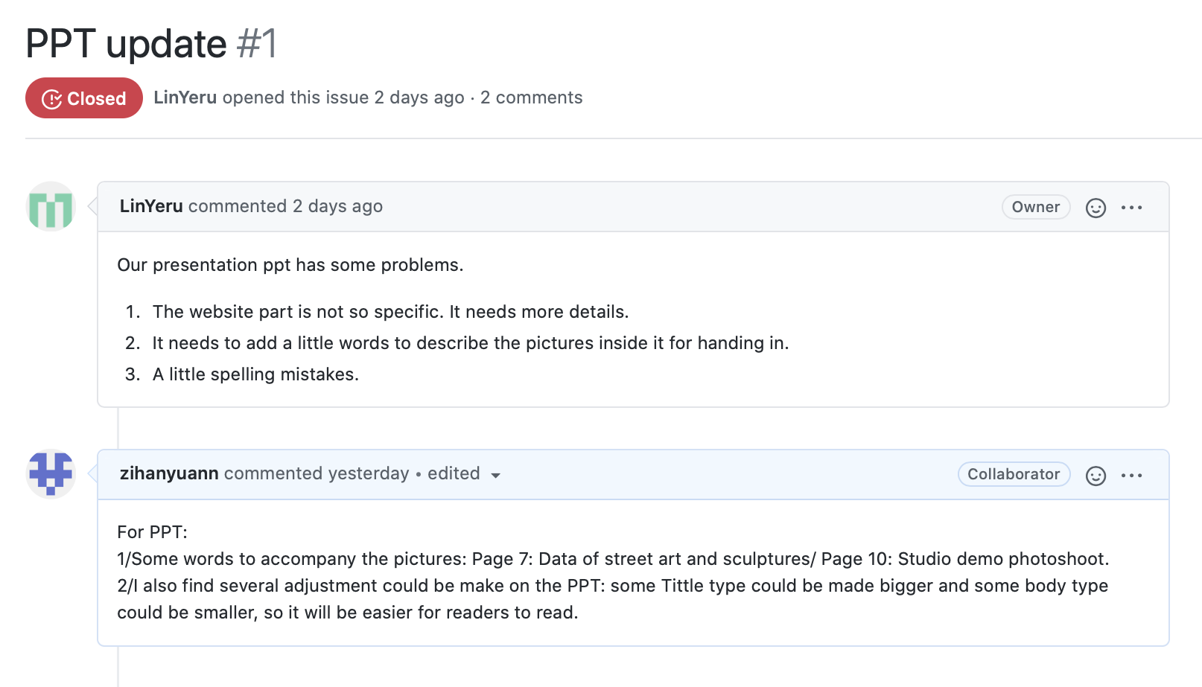

On the issue raised by Wenyun for the future work for our project as enrichment, I closed with thoughts for improving interactivity, adding more types and dimension into our work for our installation.

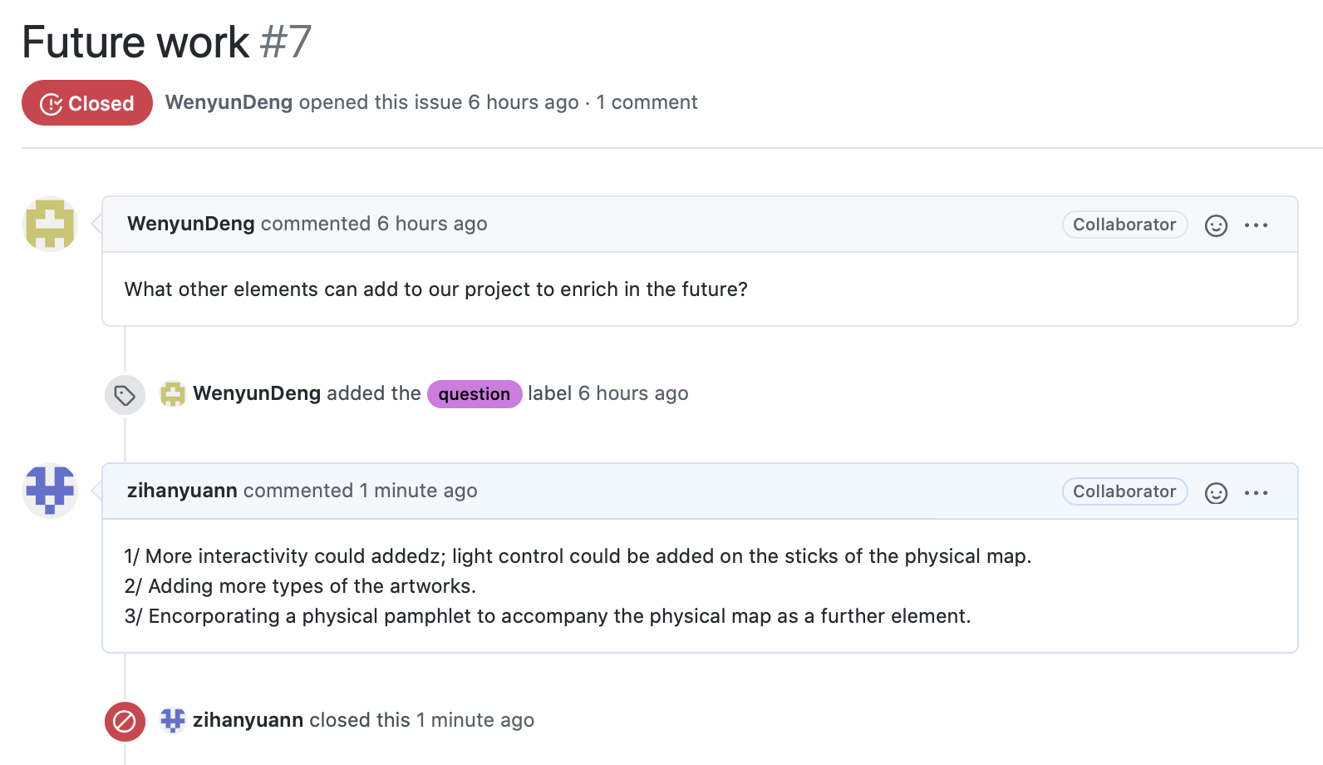

(4) **Github handle:** Ziyuaaa

**The number of commits:**

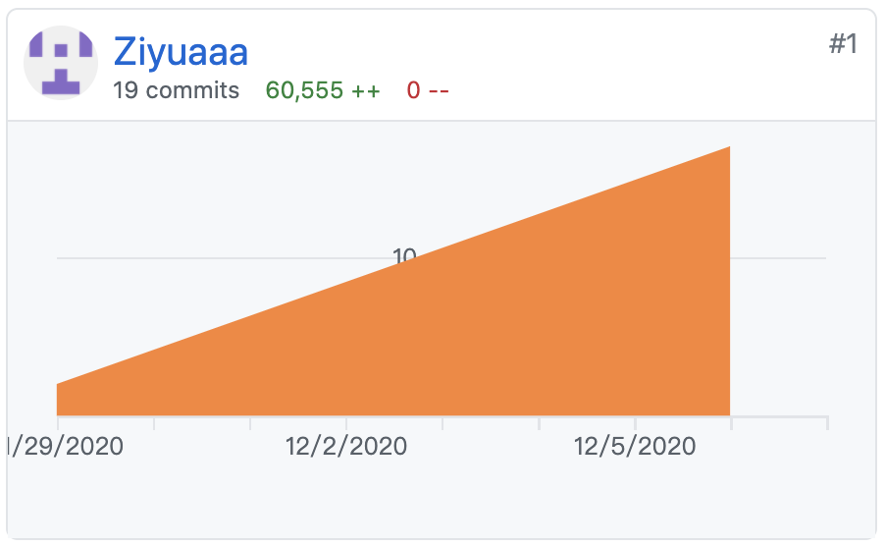

**Commits that I have made:**

1、Draws physical project material and designs layout.

Our physical map is drawn from the edges of the image, containing the exact location of Edinburgh and each of its districts. At the same time, we decided to use the Studio laser cutting machine to achieve the desired effect because we wanted to present a better effect. The AI files are identified directly by the laser cutter and resized and oriented. It iterated about 4 times respectively.

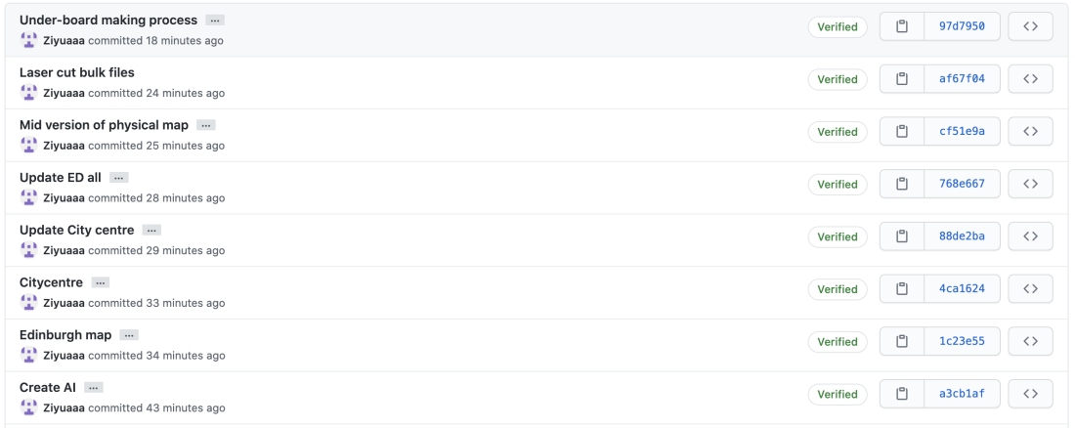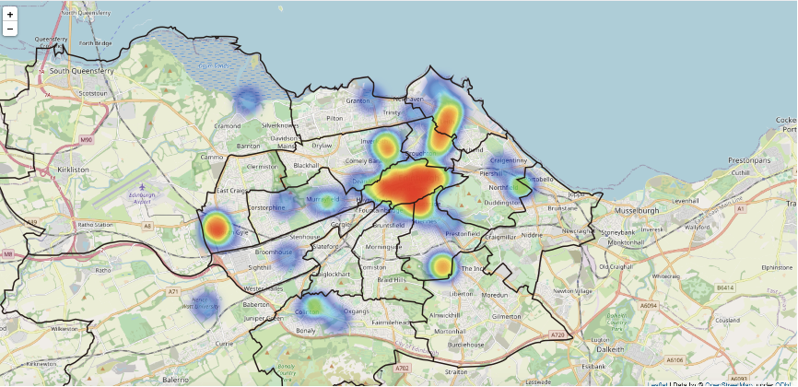

2、Shoot and produce videos of the project

There are many steps in the production of the video, and each step needs to be clearly listed to save more time and complete the homework better. This video needs to introduce the general content of the project to the viewers and provide certain knowledge supplement for the city of Edinburgh. Our interaction needs video to be clearly displayed, including controllable methods, physical presentation, etc.

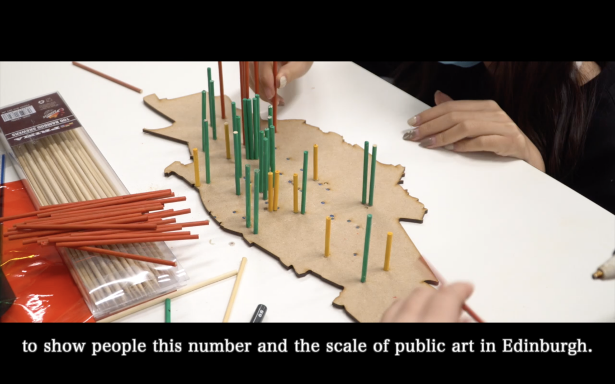

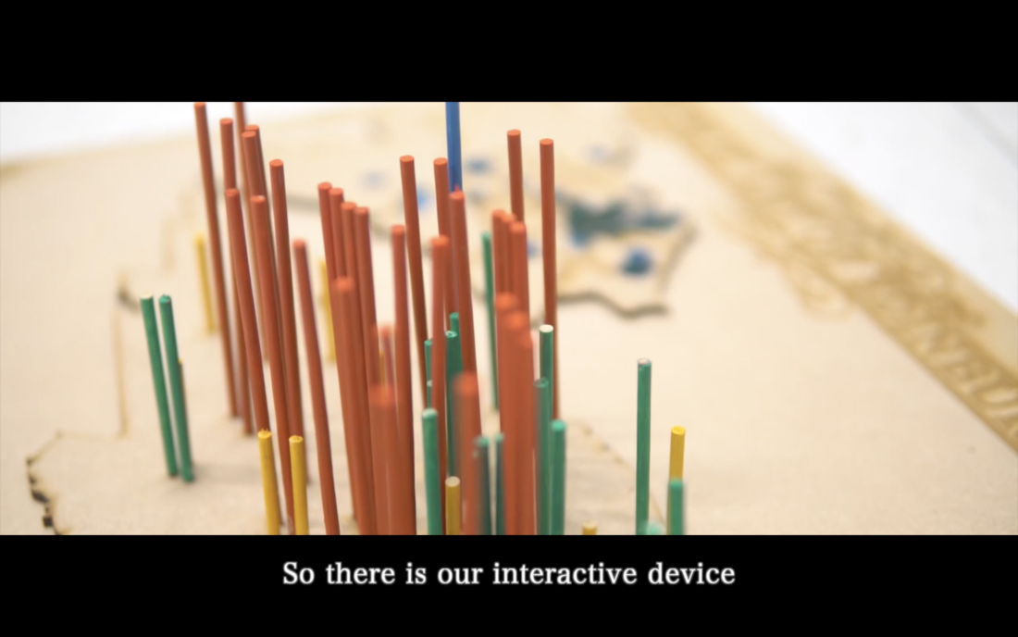

**Created issue:**

During the design process, some team members were not familiar with AI files, so the final effect was not ideal.

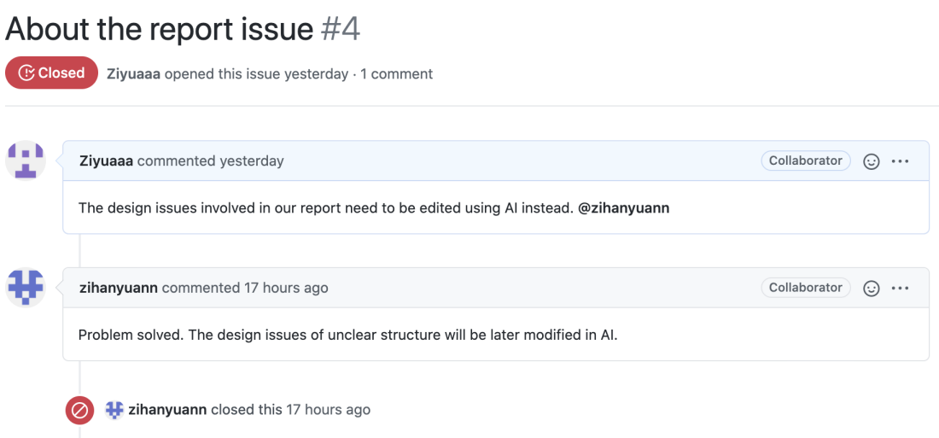

The video I produced needs subtitles to be more complete, and we are all helping to complete it together.

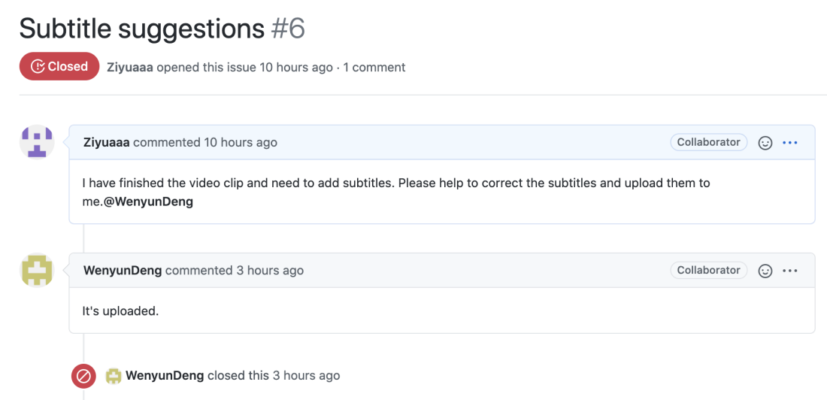

**Contribution to discussion on someone else’s issue and close the issue:**

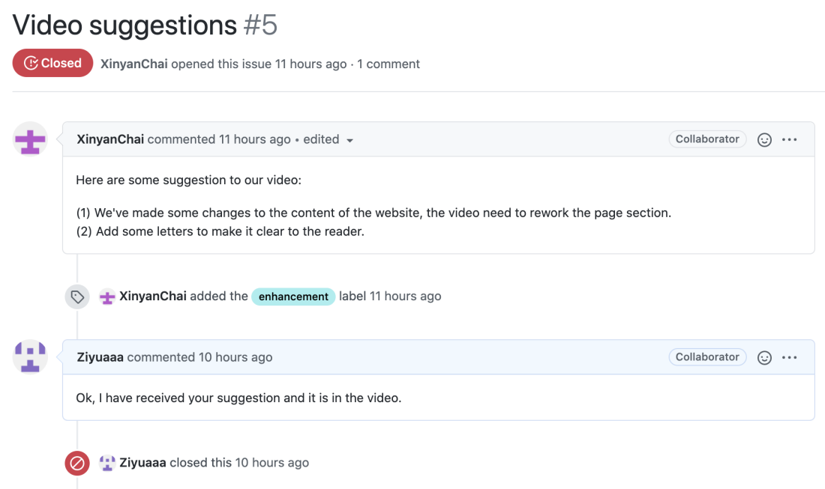

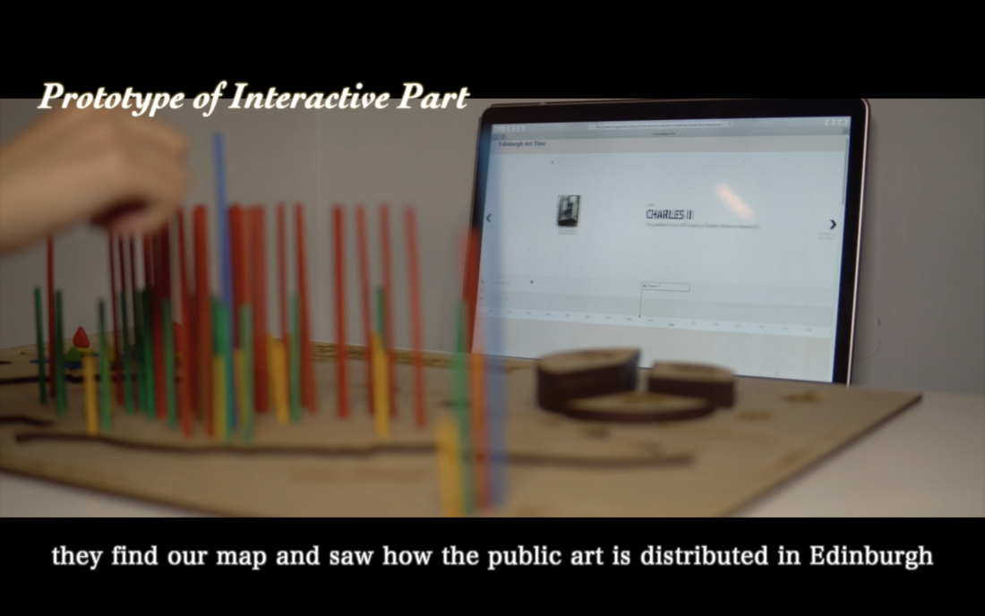

**(5) Github handle:** WenyunDeng

**Link：** https://github.com/LinYeru/culturalmap.git

**The number of commits:**

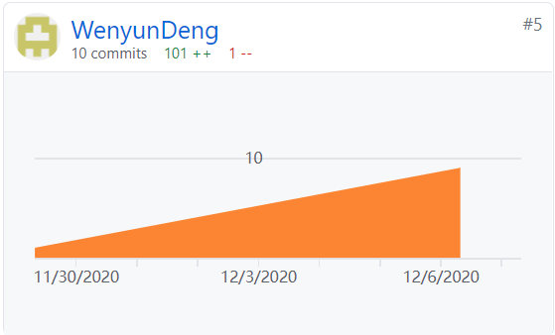

**My Commits:**

1. Web page sketch

I made the initial page of our website and the introduction interfaces within the picture of the art to provide some ideas for web design.



2. Report draft

Modified some context and writing order in the design process part of the report, try to clarify our design process.



3. Upload some modified picture of our physical map used in slides that can clarify the content, make it more reader friendly.



4. Modified some content in subtitle for the video.



5. Put some pictures into the end of the report and add some reflection.







Issue I created:

I want to explore more possibilities in the future to enrich the content and interaction way of our project, so I create this issue and Zihan made some great comments that we can work with.

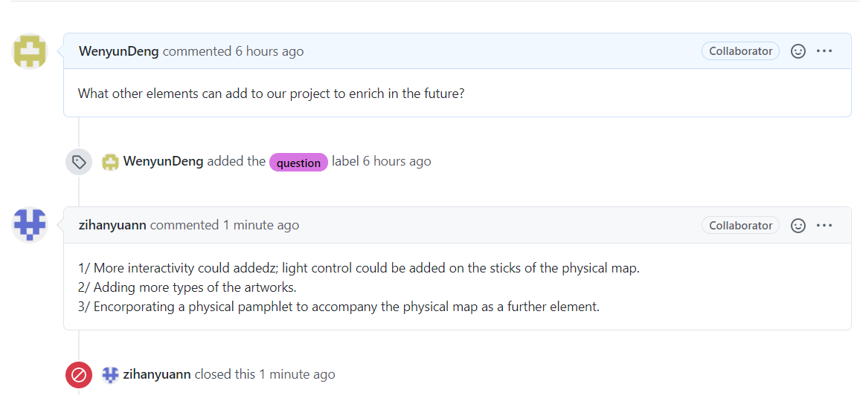

**Discussion on other’s issue:**

Our menber Zihan raised a issue about the report and we discussed about the content and the structure of the report together. I proposed some future work and some adjustments to the existing content.

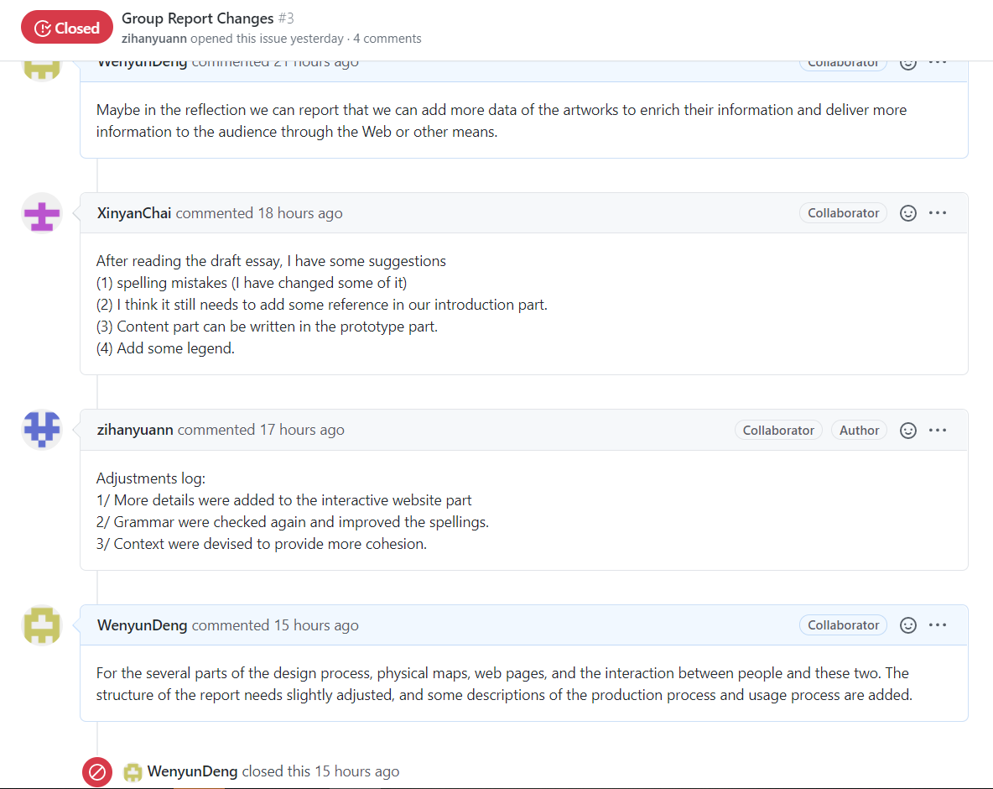

On the issue raised by Ziyu about the subtitle, we checked it together.

